DSA Lab12

23K2001

M.Muzammil Siddiqui

BCS-3J

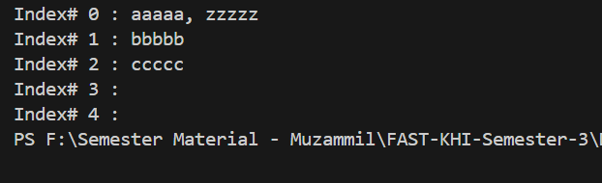Q1:

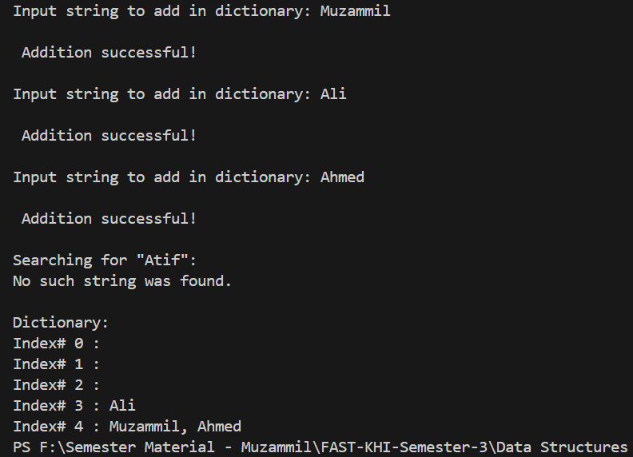Q2:

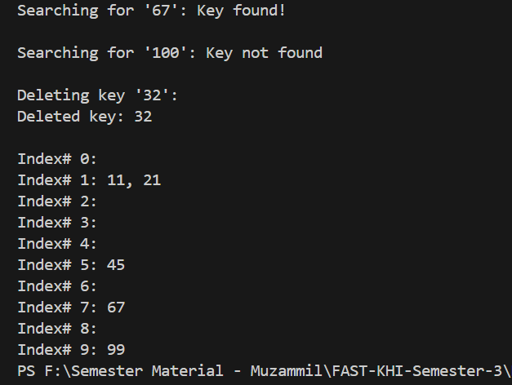Q3:

Q4:

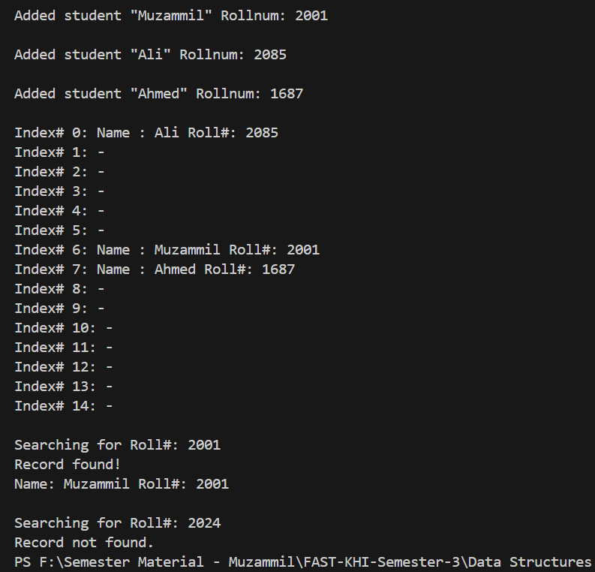Q5: